Performance Testing Phase

Date | 02-11-2025
Team ID | NM2025TMID05004
Project name | Laptop Request Catalog Item  Using ServiceNow

Introduction:
The Performance Testing phase of the Laptop Request Catalog Item Project using ServiceNow is carried out to ensure that the catalog item and its related workflows function efficiently under different load conditions.This phase focuses one valuating the system’s speed, scalability, stability, and responsiveness when multiple users simultaneously submit or track laptop requests.

Purpose of Performance Testing:
The purpose of performance testing is to verify that the ServiceNow application:
- Measure the response time of the catalog item during laptop request submission and approval processes.
- Provide users with a smooth and responsive experience throughout the request process

Objectives:
  - To evaluate response time: Ensure that the laptop request form loads quickly and processes submissions without delays.
  - To assess system stability: Verify that the catalog item performs consistently when multiple users access it at the same time.

Testing Procedure:

- Document test results, issues identified, corrective actions taken, and final performance outcomes.

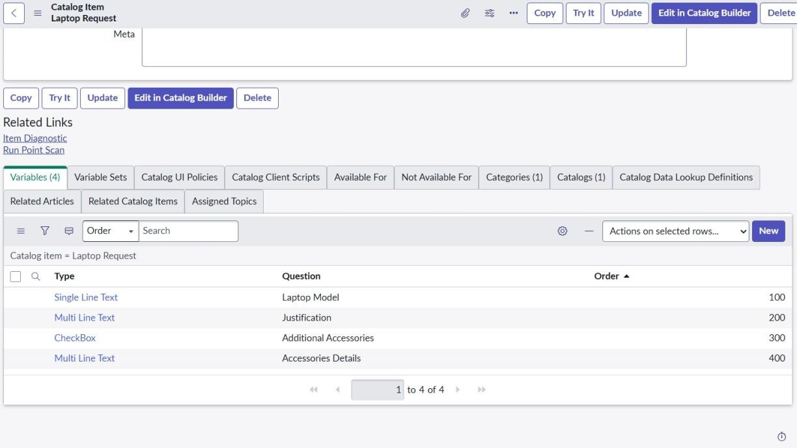
Share the performance test report with the project team and stakeholder.

Results and Observations:
  - The average response time for submitting a laptop request form was within acceptable limits, ensuring a smooth user experience.
  - The system successfully handled multiple concurrent user requests without any major slowdowns or failures.

Conclusion:
The Performance Testing of the Laptop Request Catalog Item using ServiceNow successfully verified that the system meets the required performance standards interms of speed, stability, and scalability. The testing ensured that the catalog item can handle multiple user requests simultaneously without affecting response time or functionality.

